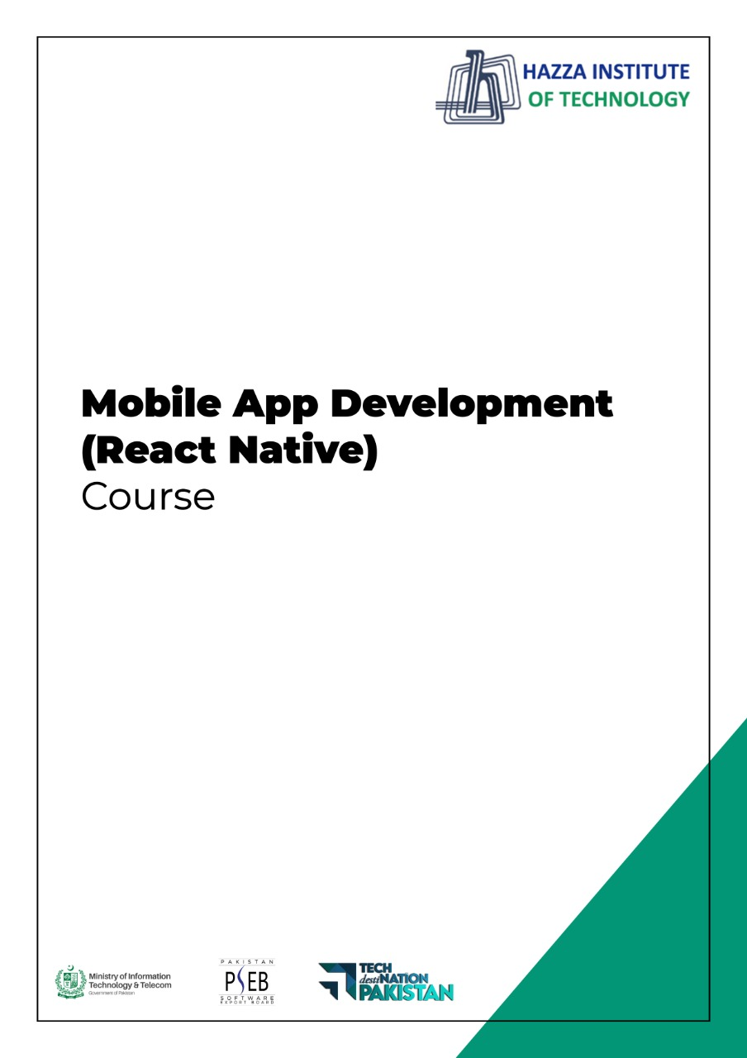
(Flutter)
Flutter Lab 14

Total Time:
3 hours (session-2)

Pre-Lab Activities:
  - Student must understand JSON and API

Learning Outcomes:
Demonstrate the knowledge of calling API with http package.
Student Activities:
  - Practicing fetching data from API

Lab Tasks:
  - Create an app that displays a list of country names and flags.
  - When clicked on a country, the details to be shown in second screen

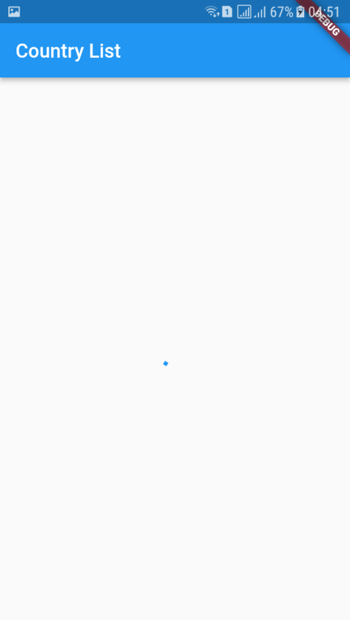
Country list screen with loding indicator

Country List Screen Populated from API
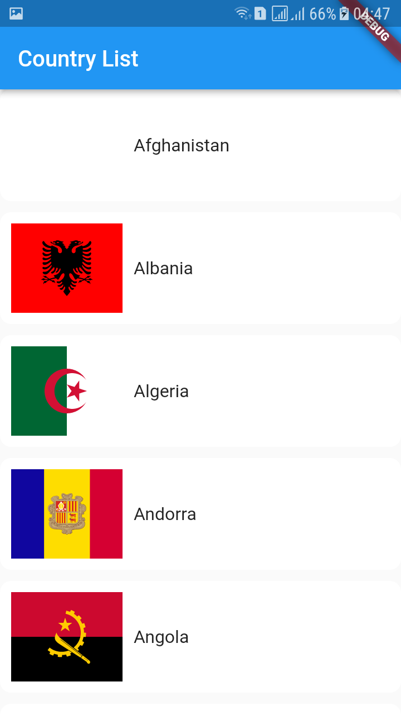

Country Detail Screen
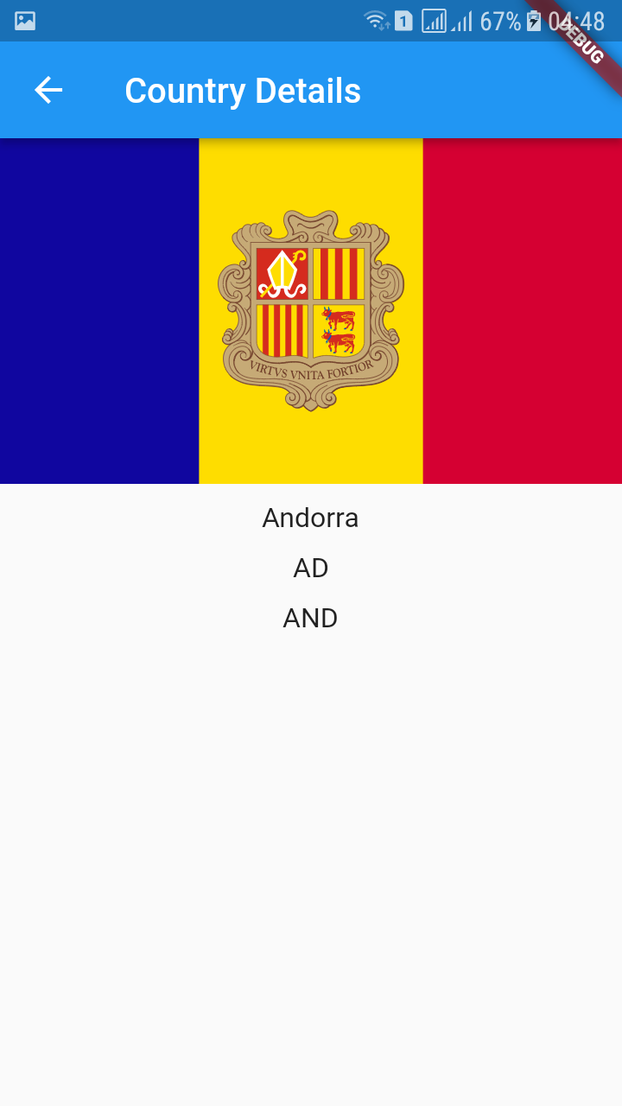

API Endpoint
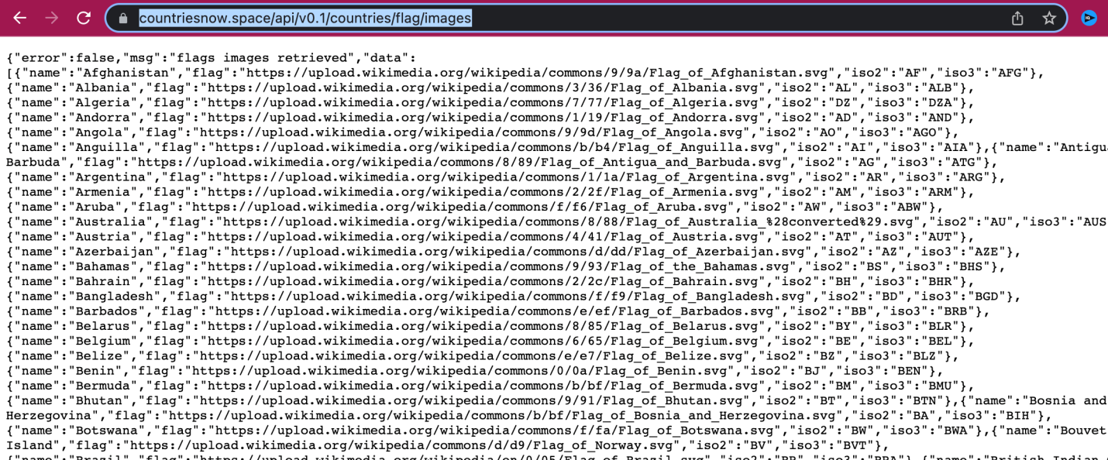

Project Structure
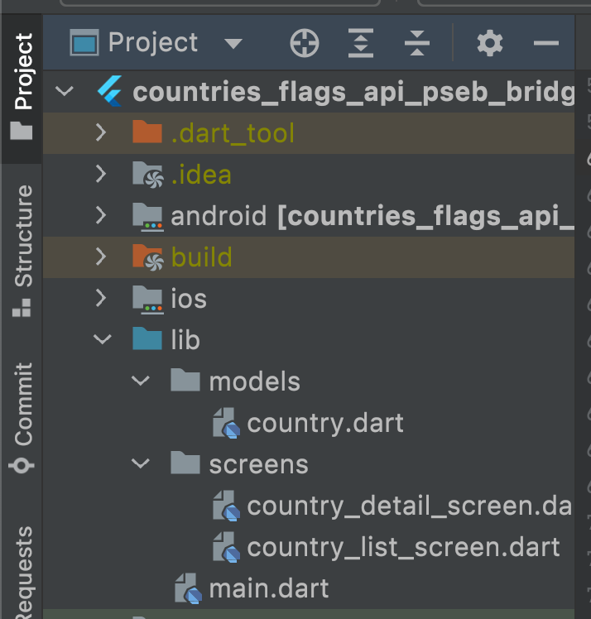

Dependencies
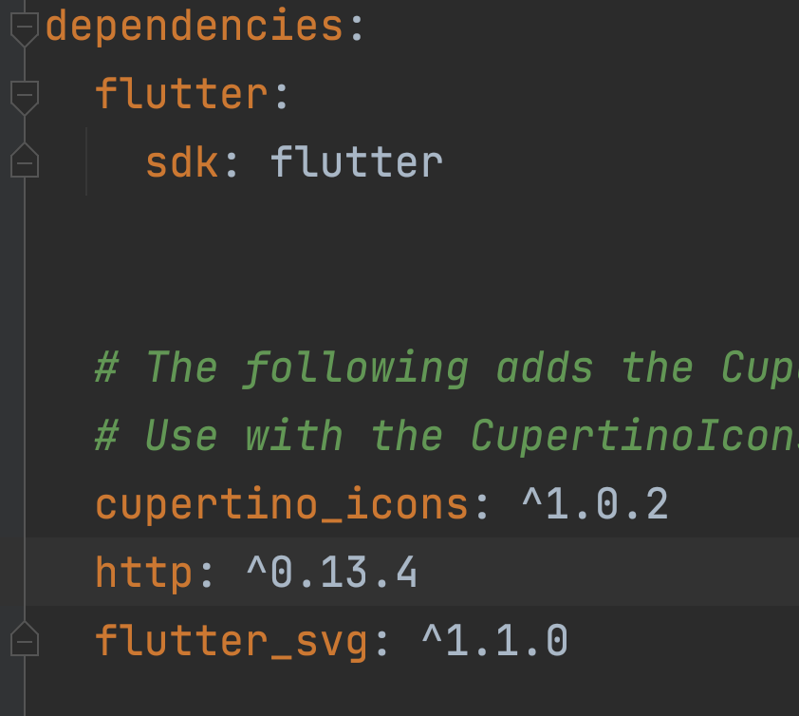

Lab Solutions:
CODE:
Model class

class Country {
late String name;
late String flag;
late String iso2;
late String iso3;

Country({
required this.name,
required this.flag,
required this.iso2,
required this.iso3,
});

Country.fromJson( Map<String, dynamic> map){
name = map['name'];
flag = map['flag'];
iso2 = map['iso2'];
iso3 = map['iso3'];
}
}

Country List Screen

import 'dart:convert';

import 'package:countries_flags_api_pseb_bridge/screens/country_detail_screen.dart';
import 'package:flutter/material.dart';
import 'package:flutter_svg/svg.dart';

import '../models/country.dart';
import 'package:http/http.dart' as http;

class CountryListScreen extends StatefulWidget {
const CountryListScreen({Key? key}) : super(key: key);

@override
State<CountryListScreen> createState() => _CountryListScreenState();
}

class _CountryListScreenState extends State<CountryListScreen> {
Future<List<Country>> getAllCountries() async {
const url = 'https://countriesnow.space/api/v0.1/countries/flag/images';

var response = await http.get(Uri.parse(url));

if (response.statusCode == 200) {
var jsonResponse = json.decode(response.body);

var jsonCountries = jsonResponse['data'];

List<Country> countries = [];
for (var jsonCountry in jsonCountries) {
Country country = Country.fromJson(jsonCountry);
countries.add(country);
}

return countries;
} else {
return <Country>[];
}
}

@override
Widget build(BuildContext context) {
return Scaffold(
appBar: AppBar(
title: const Text('Country List'),
),
body: FutureBuilder<List<Country>>(
future: getAllCountries(),
builder: (context, snapshot){
if( snapshot.data == null){
return const Center(child: CircularProgressIndicator(),);
}else{
List<Country> countries = snapshot.data!;

return ListView.builder(
itemCount: countries.length,
itemBuilder: (context, index){

Country country = countries[index];

return GestureDetector(
onTap: (){
Navigator.of(context).push(MaterialPageRoute(builder: (context){
return CountryDetailScreen(country: country);
}));
},
child: Container(
padding: const EdgeInsets.all(10),
margin: const EdgeInsets.only(bottom: 10),
decoration: BoxDecoration(
color: Colors.white,
borderRadius: BorderRadius.circular(10),
),
child: Row(
children: [
SizedBox(
width: 100,
height: 80,
child: SvgPicture.network(country.flag, fit: BoxFit.cover,)),

const SizedBox(width: 10,),

Text(country.name, style: const TextStyle(fontSize: 16),)
],
),
),
);

});
}
},
),
);
}
}

Country Detail Screen

import 'package:flutter/material.dart';
import 'package:flutter_svg/svg.dart';

import '../models/country.dart';

class CountryDetailScreen extends StatefulWidget {
final Country country;
const CountryDetailScreen({Key? key, required this.country}) : super(key: key);

@override
State<CountryDetailScreen> createState() => _CountryDetailScreenState();
}

class _CountryDetailScreenState extends State<CountryDetailScreen> {
@override
Widget build(BuildContext context) {
return Scaffold(
appBar: AppBar(
title: const Text('Country Details'),
),
body: Column(
children: [
SizedBox(
width: double.infinity,
height: 200,
child: SvgPicture.network(widget.country.flag, fit: BoxFit.cover,),
),
const SizedBox(height: 10,),
Text(widget.country.name, style: const TextStyle(fontSize: 16),),
const SizedBox(height: 10,),
Text(widget.country.iso2, style: const TextStyle(fontSize: 16),),
const SizedBox(height: 10,),
Text(widget.country.iso3, style: const TextStyle(fontSize: 16),)

],
),
);
}
}

